SE LAB-3

NAME: AARIZ D
SRN: PES1UG24AM330
DATE: 16/09/2026

UML diagram:

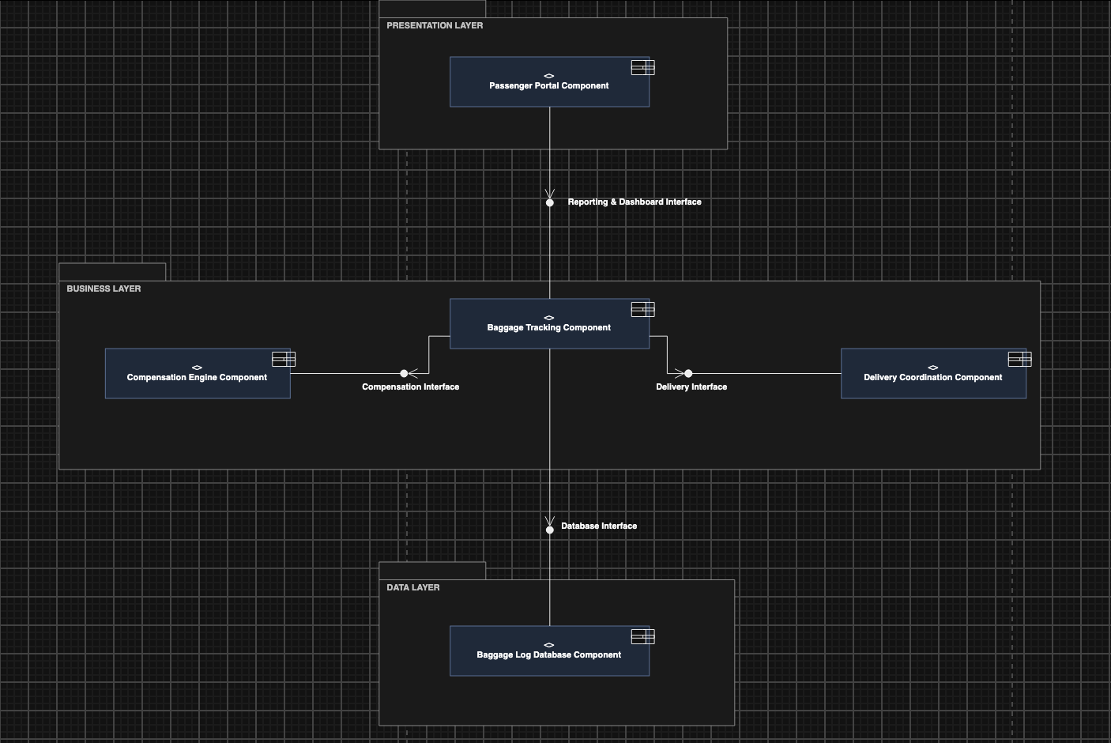

Justification:

Architecture Selection: Layered Architecture
Architectural Choice Justification:
- Clear Functional Isolation: Managing lost baggage requires distinct separation between user interactions, business workflows, and log processing. By using a layered structure, frontend multilingual dashboard rendering remains decoupled from background scan processing, compensation calculation logic, and courier dispatch APIs.
- Maintainability and Simplicity: A layered approach organizes core system processes cleanly without introducing the complexity of microservices. System maintainers can update third-party delivery variables or retune payment calculation algorithms independently without breaking UI/UX components.
Security Advantage:
By enforcing strict horizontal boundaries, passenger interactions through the Passenger Portal Component cannot access the underlying Baggage Log Database Component directly. All requests must route through verified execution pathways in the Business Layer. This design prevents unauthorized direct queries against internal flight scan logs, protecting sensitive passenger profile data.
Performance Benefit:
Keeping core tracking and cross-referencing logic within localized application layers eliminates inter-service network hops. Direct database access from the business logic tier supports query optimization and caching, allowing the system to easily achieve sub-200ms API response times for scan history retrievals, even during peak travel surges.

